**TABLE OF FIGURES**

Figure 1 First and Second testing [code] 2

Figure 2 First and Second testing [result] 2

Figure 3 First and Second testing [code (both pass)] 3

Figure 4 First and Second testing [result (both pass)] 3

Figure 5 First and Second testing [code (both fail)] 4

Figure 6 First and Second testing [result (both fail)] 4

Figure 7 Third and Fourth testing [code] 5

Figure 8 Third and Fourth testing [result] 5

Figure 9 Third and Fourth testing [code & result (both pass)] 6

Figure 10 Fifth testing[code] 7

Figure 11 Fifth testing[result] 7

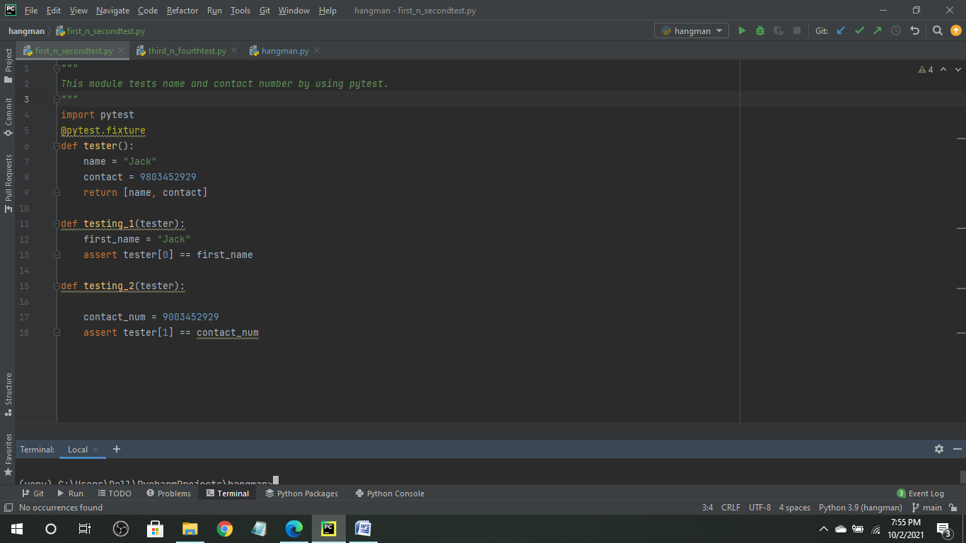

Figure 1 First and Second testing [code]

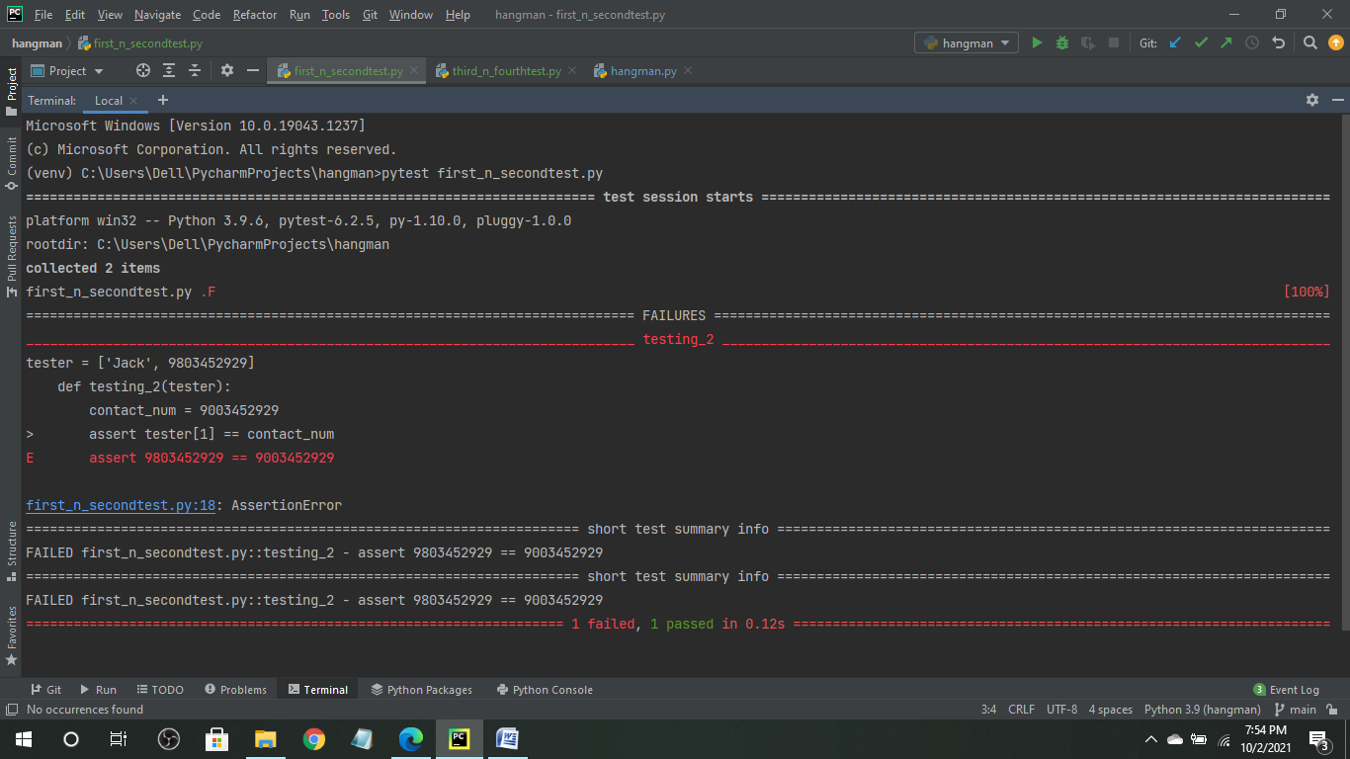

Figure 2 First and Second testing [result]

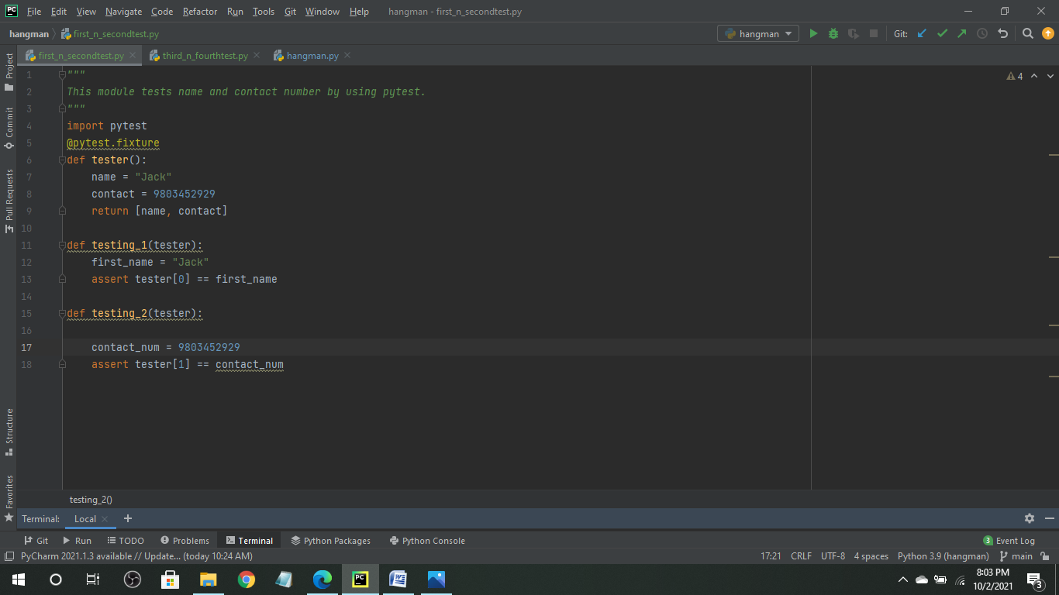

Figure 3 First and Second testing [code (both pass)]

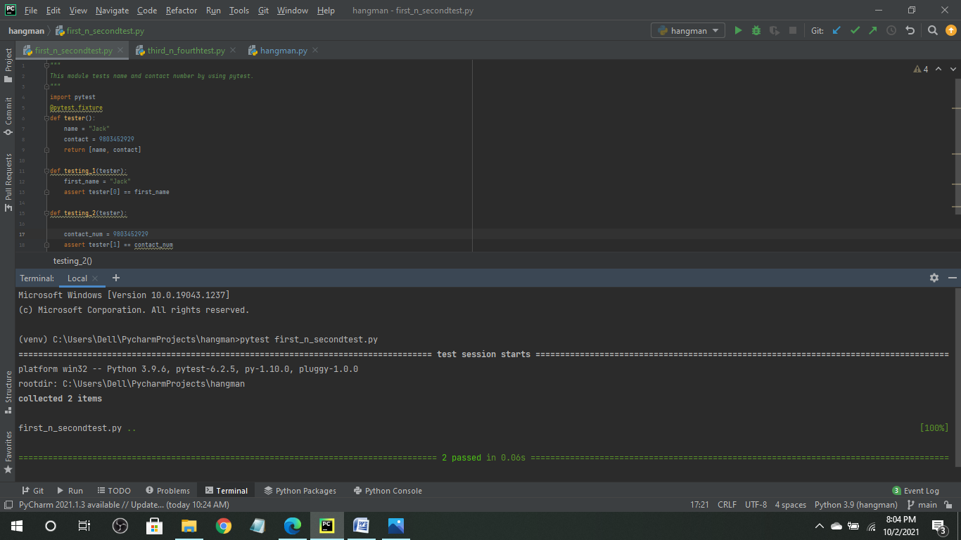

Figure 4 First and Second testing [result (both pass)]

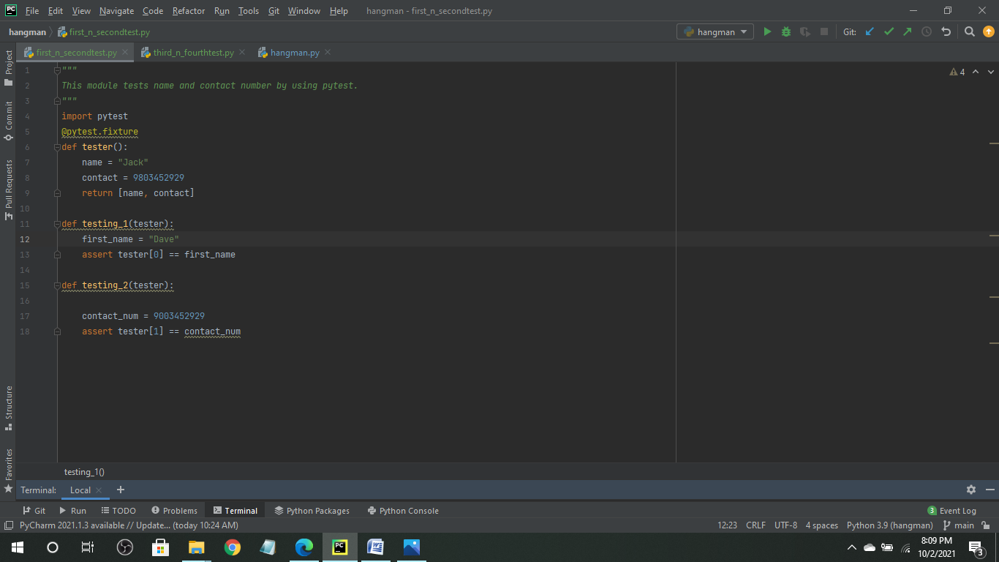

Figure 5 First and Second testing [code (both fail)]

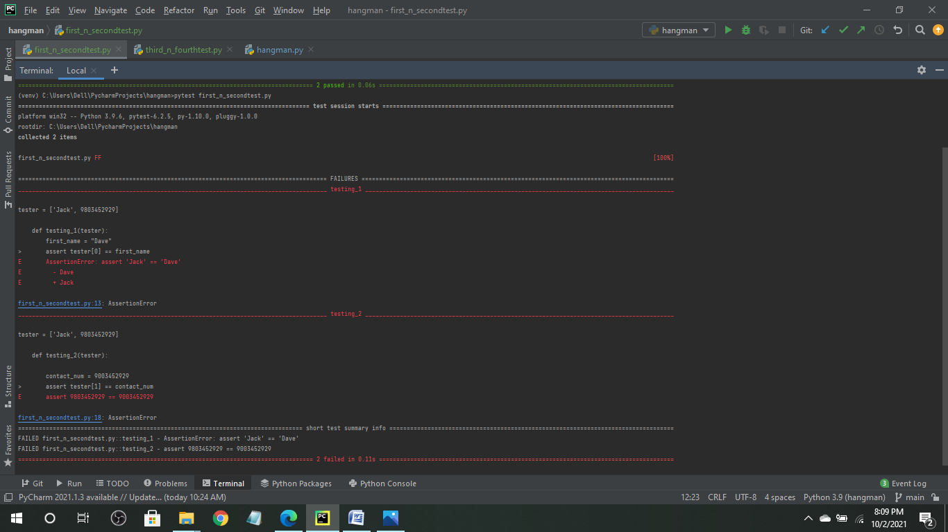

Figure 6 First and Second testing [result (both fail)]

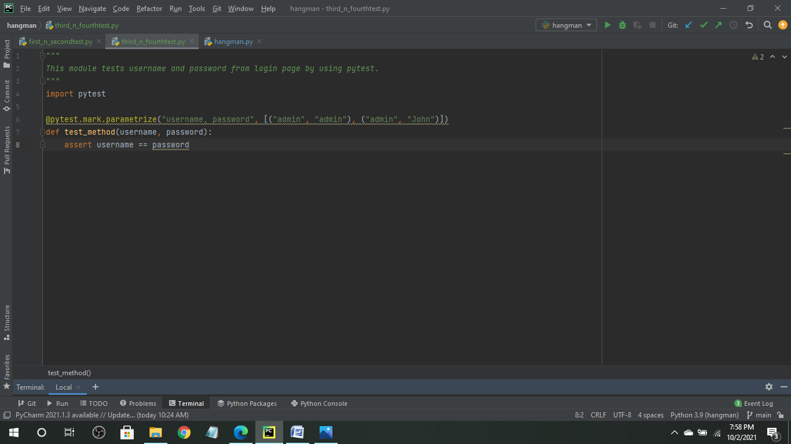

Figure 7 Third and Fourth testing [code]

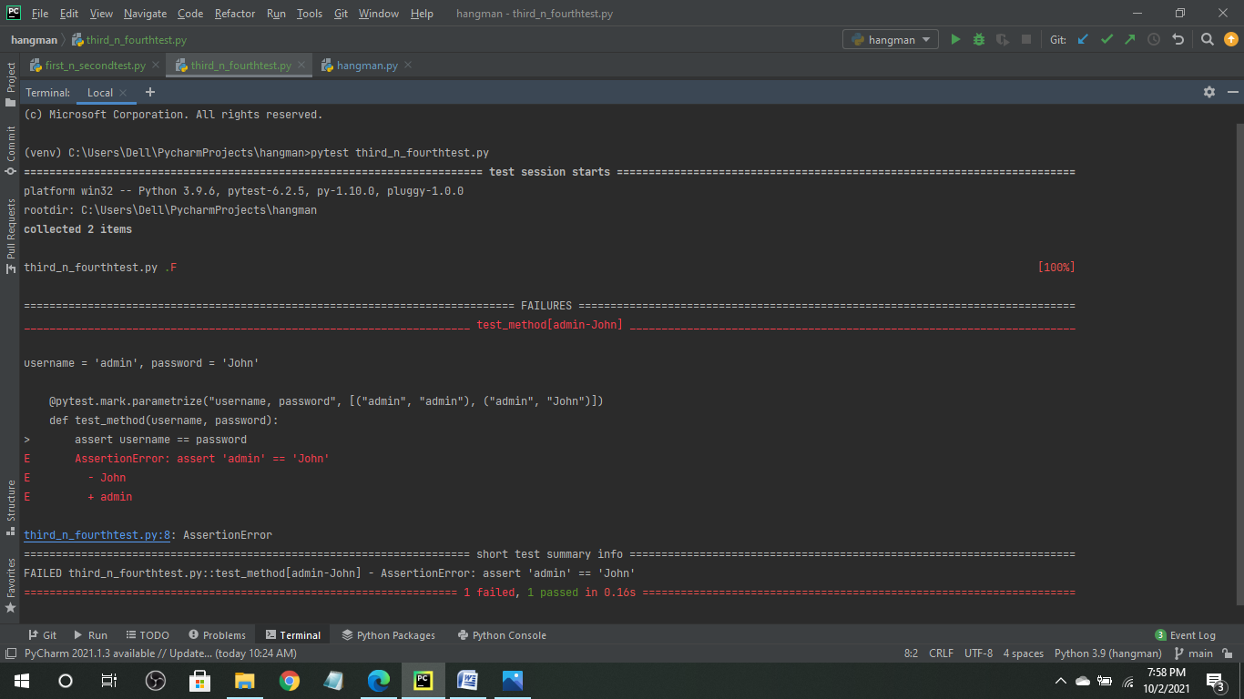

Figure 8 Third and Fourth testing [result]

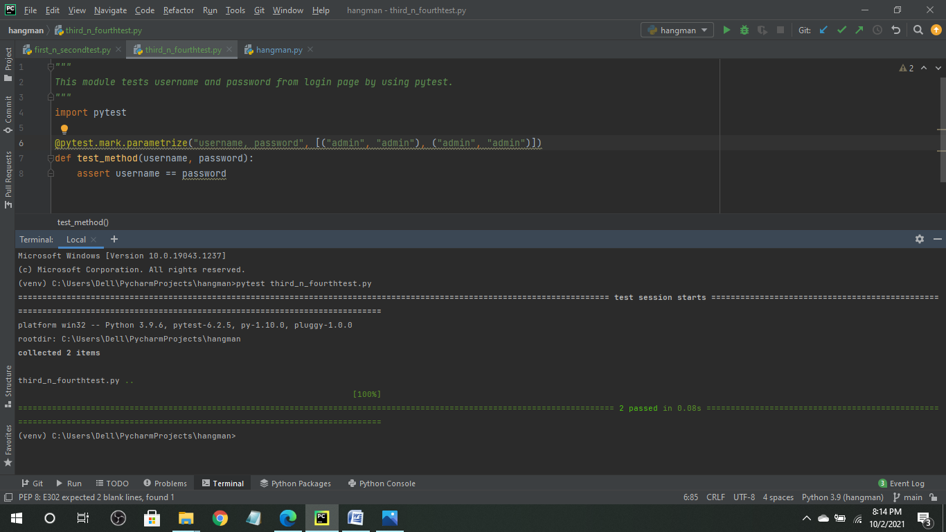

Figure 9 Third and Fourth testing [code & result (both pass)]

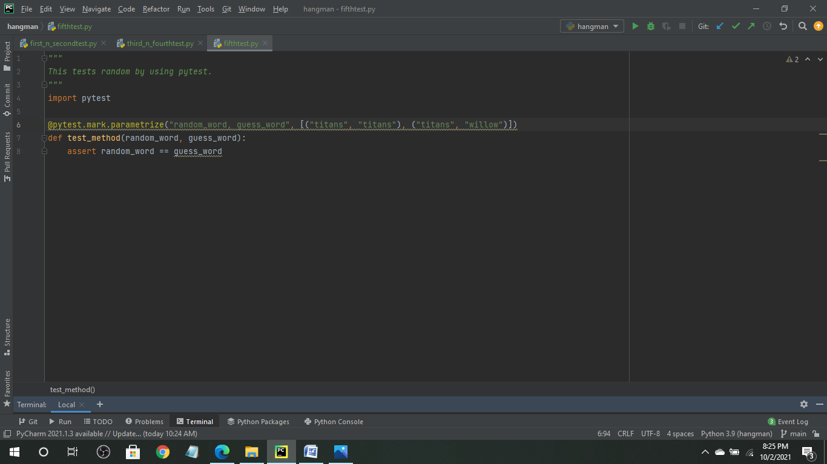

Figure 10 Fifth testing[code]

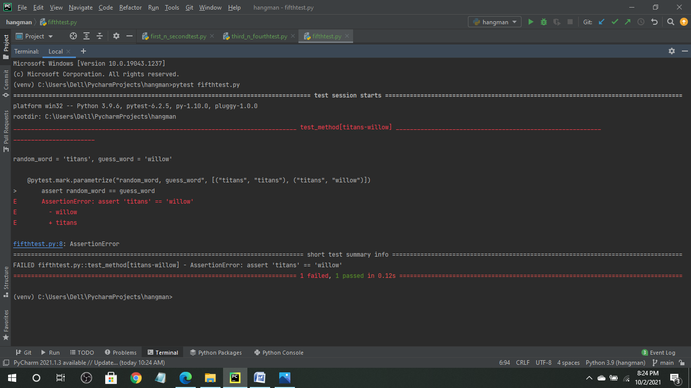

Figure 11 Fifth testing[result]